**Assignment 16 - 9-Apr**

**Problem Statement 1:**

A test is conducted which is consisting of 20 MCQs (multiple choices questions) with every MCQ having its four options out of which only one is correct. Determine the probability that a person undertaking that test has answered exactly 5 questions wrong.

**Solution –**

Here, n = 20, n - k = 5, k = 20 - 5 = 15

Here the probability of success = probability of giving a right answer = s = 1/4

Hence, the probability of failure = probability of giving a wrong answer = 1 - s

= 1 – 1/4 = 3/4

When we substitute these values in the formula for Binomial distribution we get,

So, P (exactly 5 out of 20 answers incorrect) = C (20, 5) * (1/4) ^ 15 * (3/4) ^ 5

→ P (5 out of 20) = (20∗19∗18∗17∗16) / (5∗4∗3∗2∗1) * (1/4) ^ 15 * (3/4) ^ 5

= 0.0000034 (approx)

Thus the required probability is **0.0000034** approximately.

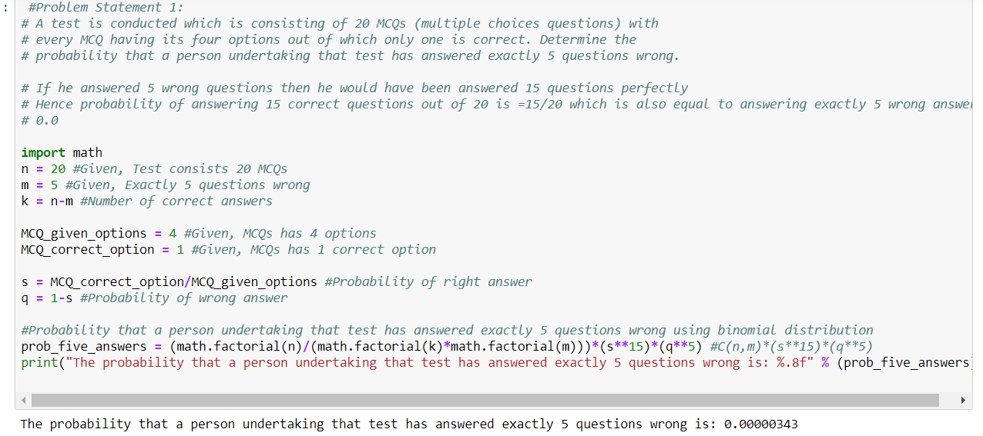

**Problem Statement 2:**

A die marked A to E is rolled 50 times. Find the probability of getting a “D” exactly 5 times.

**Solution –**

Here, n = 50, k = 5, n - k = 45.

The probability of success = probability of getting a “D”= s = 1/5

Hence, the probability of failure = probability of not getting a “D” = 1 - s = **4/5**.

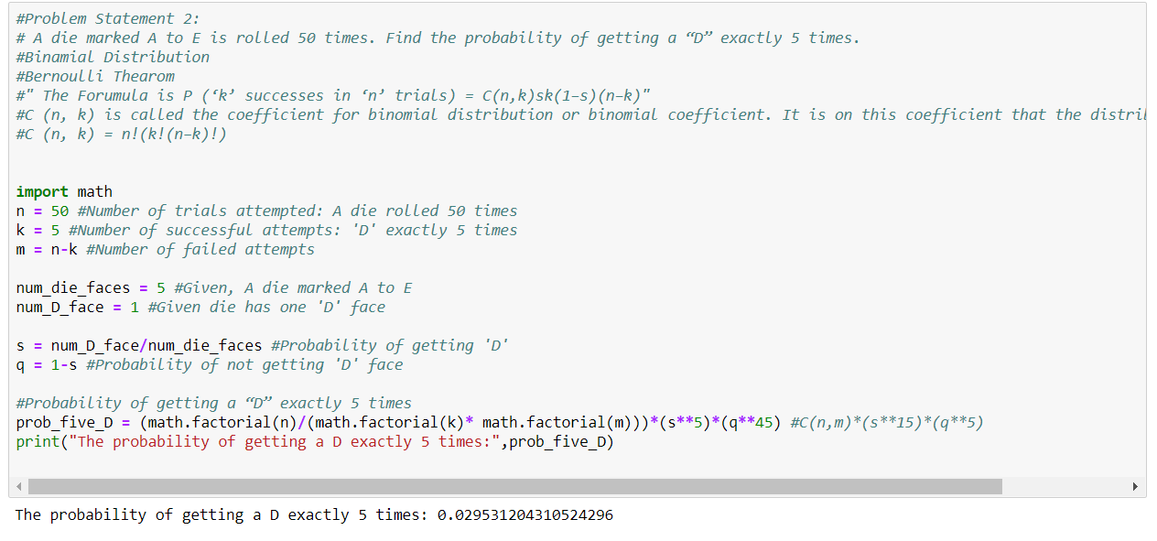

**Problem Statement 3:**

Two balls are drawn at random in succession without replacement from an urn containing 4 red balls and 6 black balls. Find the probabilities of all the possible outcomes.

**Solution –**

First determine the probabilities of the events.

**Events Probability**

RR = (4/10)(3/9) = 2/15

RB = (4/10)(6/9) = 4/15

BR = (6/10)(4/9) = 4/15

BB = (6/10)(5/9) = 1/3

The probability of 0 blue balls (RR) is 2/15

The probability of 1 blue ball is (RB or BR) is 4/15+4/15 = 8/15

The probability of 2 blue balls (BB) is 1/3

So the probability distribution is: Z p(Z)

--------

0 = **2/15**

1 = **8/15**

2 = **1/3**

